EASWARI ENGINEERING COLLEGE
(AUTONOMOUS)
CENTRE FOR ENTREPRENEURSHIP DEVELOPMENT
SHE-STARTUP EDITION
EVENT PHOTO:
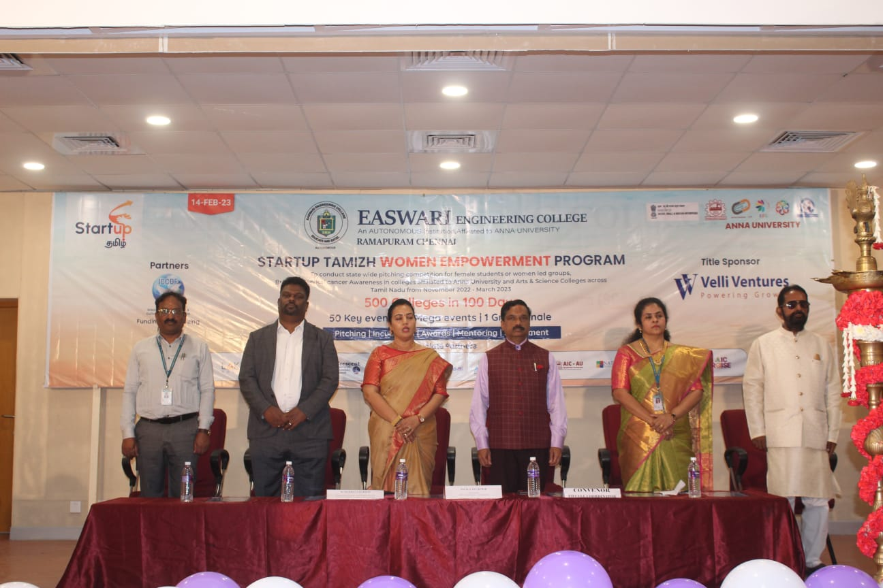

EVENT REPORT:
Easwari Engineering College, Centre for Entrepreneurship Development in association with Anna University and ICCDF hosted the program “SHE startup Tamil Edition” at our campus for all girl students interested in Entrepreneurship. The event started with tree plantation by all the guests and followed by inauguration of the event.
The inaugural function started with welcome address by Dr.Saikumari.V, Prof & Head -MBA and EEC- CED coordinator. The special address by Dr.Sharmila Nagarajan , Founder and Chairwomen velli ventures . The felicitation for the guest done by Vice Principal Admin.
The following guest were invited for the session
Dr. Sharmila Nagarajan, founder and chairwomen –Velli Ventures & ICCDF and startup Tamizh founder and investment head.
Prof Dr. G.Ravikumar , Registrar , Anna University (Chief guest )
Mr. Mohanraj, Managing Director - Orio trading software solutions pvt ltd.
The chief guest and guest of honour insisted students to come out with business models and innovative ideas for business. They also shared the opportunities available for students for starting up their own venture. Totally 98 students participated in the pitching session. The event ended with cancer awareness program for girls and followed by vote of thanks.
EVENT POSTER:
