EASWARI ENGINEERING COLLEGE
(Autonomous)
Centre for Entrepreneurship Development- Activities
PITCH TALK SESSIONS
1. Pitch Talk session by IT department held on 27/1/2023.
Event Poster:
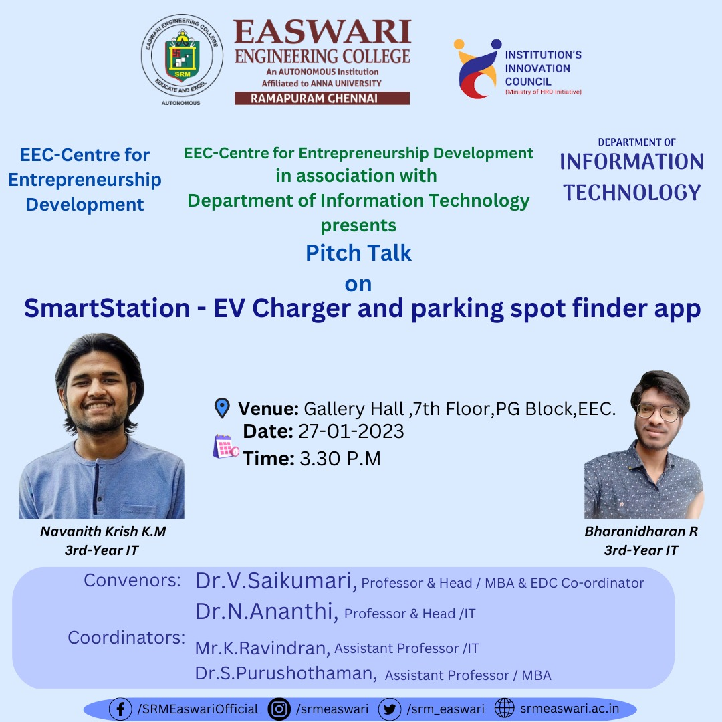
Event Report:
The Centre for Entrepreneurship Development of Easwari Engineering College started the 'Pitch talk' session for CED EEC students. The session started with welcome address given by Dr.Saikumari.V, Prof & Head MBA and EEC CED coordinator .IT department EDC coordinator motivated the team. The students of information technology department presented their business idea on the title “Smart EV charger and parking system”. The students of IT and MBA attended the session along with MBA faculty and EDC coordinator.
Event Photo:
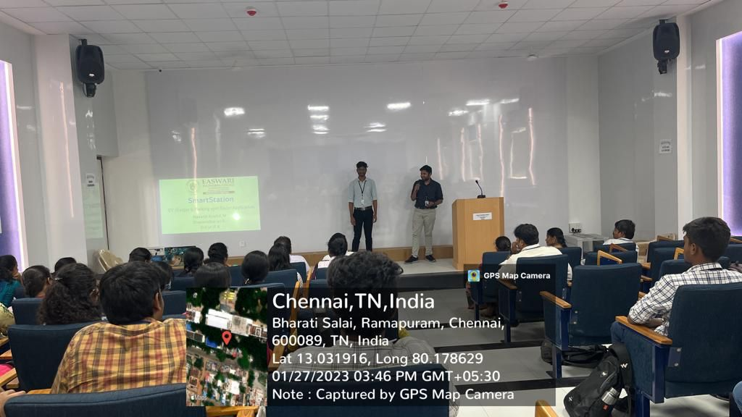
2. Pitch Talk Session by ECE department
Event Poster:
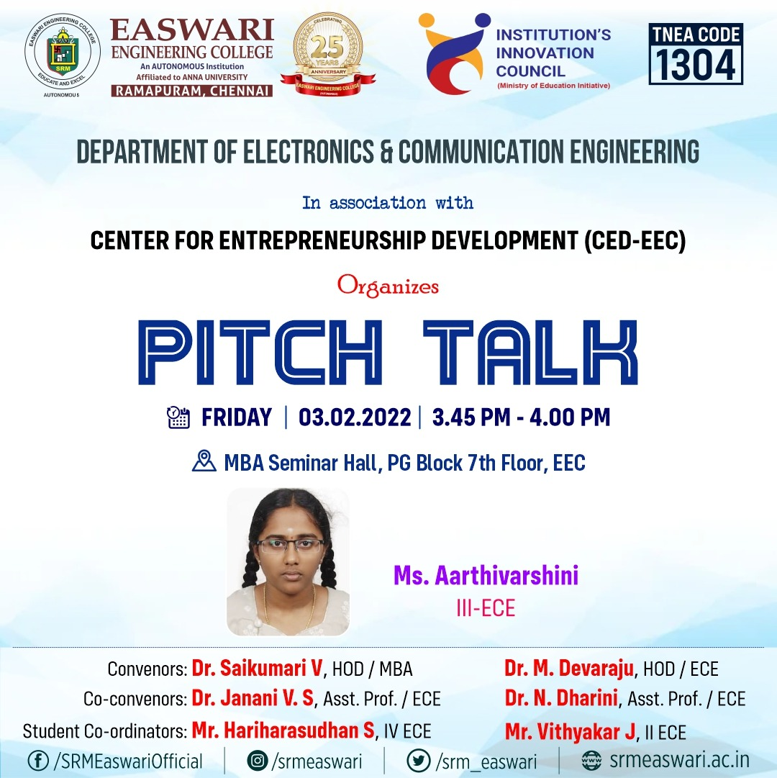
Event Report:
The Centre for Entrepreneurship Development of Easwari Engineering College completed the 'Pitch talk' session for CED EEC students. The session started with welcome address given by Dr.Saikumari.V, Prof & Head MBA and EEC CED coordinator . The students of ECE department presented their business idea on the title “IOT”. The students of ECE and MBA attended the session along with MBA faculty and other engineering department EDC coordinator.
Event Photo:
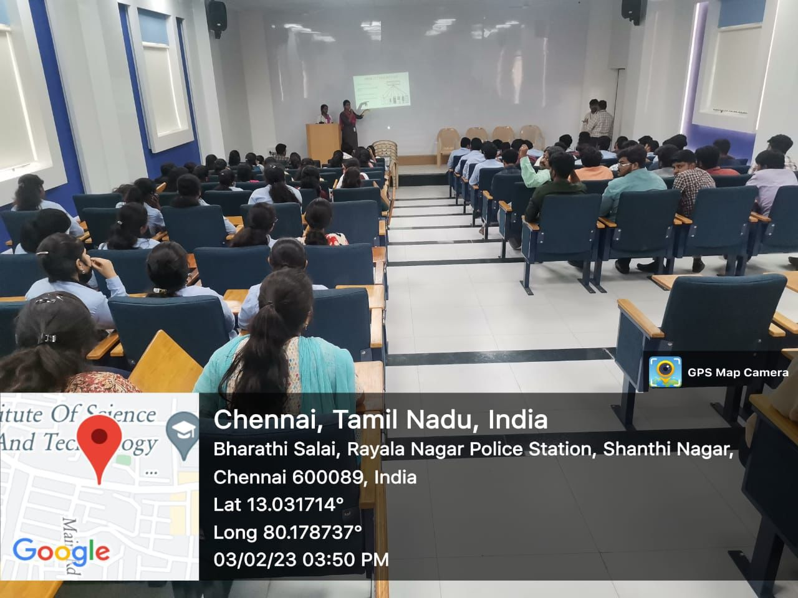
3. Pitch Talk session by RA Dept
Event Poster:
Event Report:
The Centre for Entrepreneurship Development of Easwari Engineering College completed the 'Pitch talk' session for CED EEC students. The session started with welcome address given by Dr.Saikumari.V, Prof & Head MBA and EEC CED coordinator .
The special address for the session given by VP-Academic and HOD- R&A, he appreciate the Initiative taken by the Centre for Entrepreneurship Development and insisted students from other UG branches to participate and explore the opportunities.

The student Mr Bebin joe from Robotics and automation department presented his pitching idea on the title innovative variable gear. The students of R&A and MBA attended the session along with MBA faculty and other engineering departments EDC coordinators.
Event Photo:
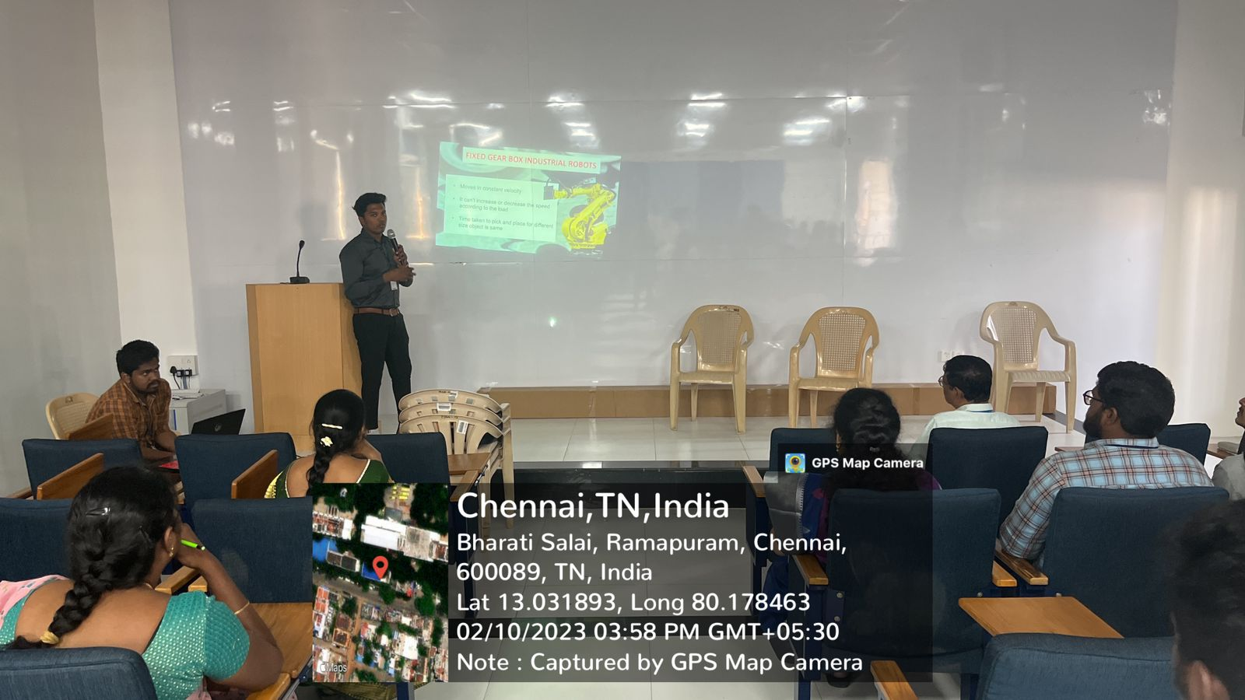
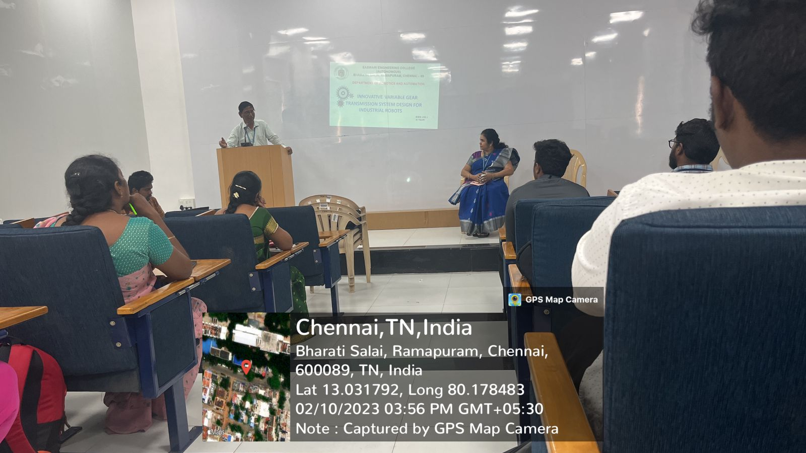
4.Pitch Talk session by MBA Department
Event Poster:
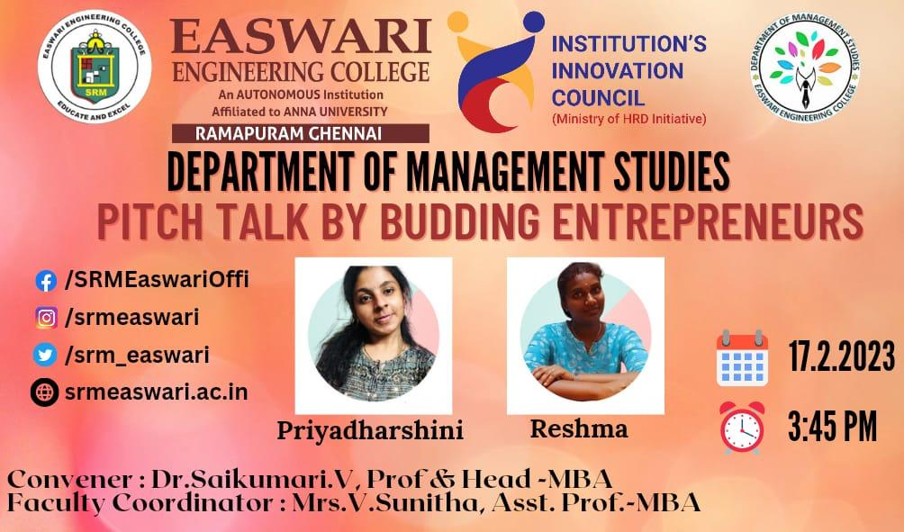
Event Report:
The Centre for Entrepreneurship Development of Easwari Engineering College completed the 'Pitch talk' session for CED EEC students. The session started with welcome address given by Dr.Saikumari.V, Prof & Head MBA and EEC CED coordinator .
The students of MBA Priyadharshini and Reshma presented their business ideas to the students. The session ended with question and answer from students.
Event Photo:
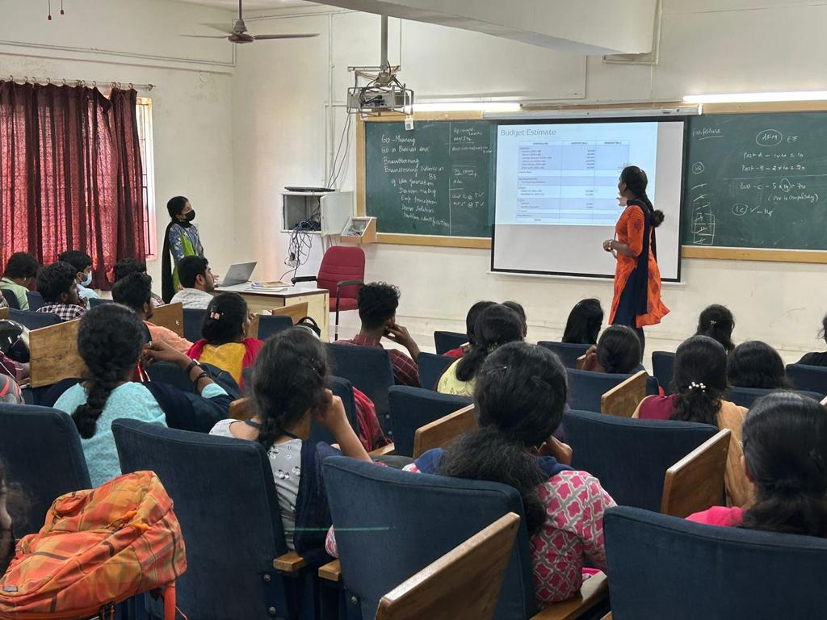

5. Pitch Talk session by BME Dept
Event Poster:
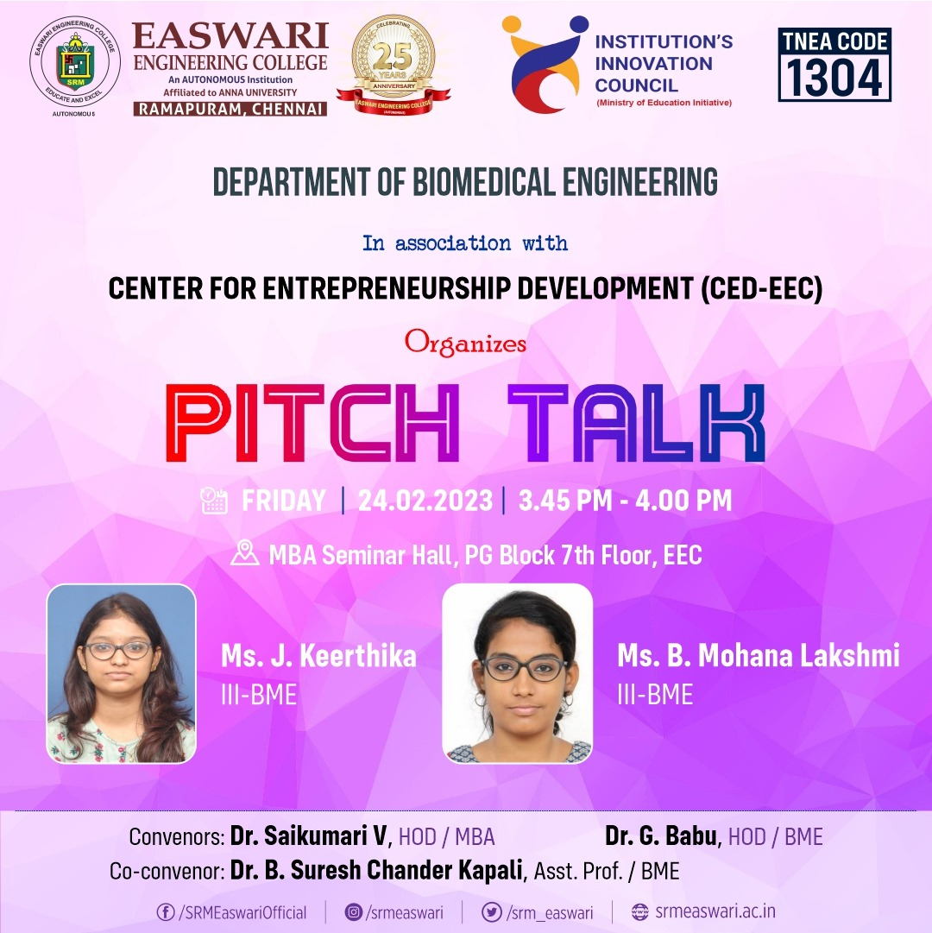
Event Report:
The Centre for Entrepreneurship Development of Easwari Engineering College completed the 'Pitch talk' session for CED EEC students. The session started with welcome address given by Dr.Saikumari.V, Prof & Head MBA and EEC CED coordinator .BME department EDC coordinator motivated the team. The students of BME department presented their business idea on the title “continuous noninvasive glucose monitoring device using NIR sensor“ . The students of BME attended the session along with EDC coordinators.
Event Photo:
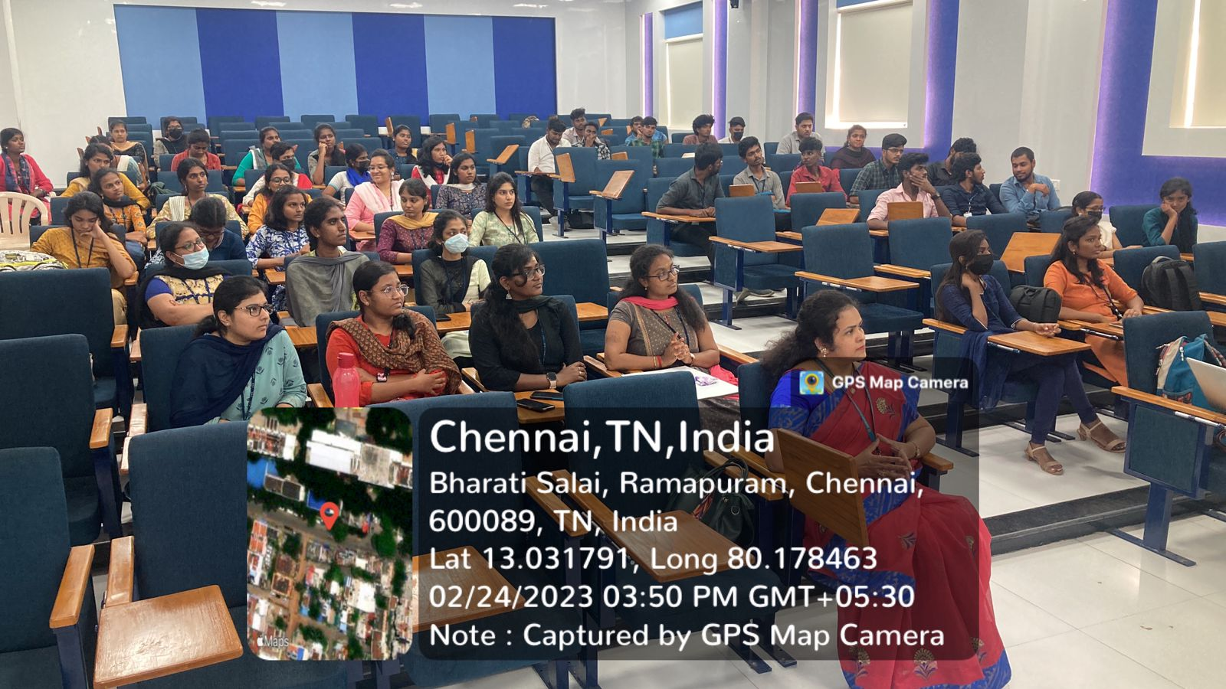
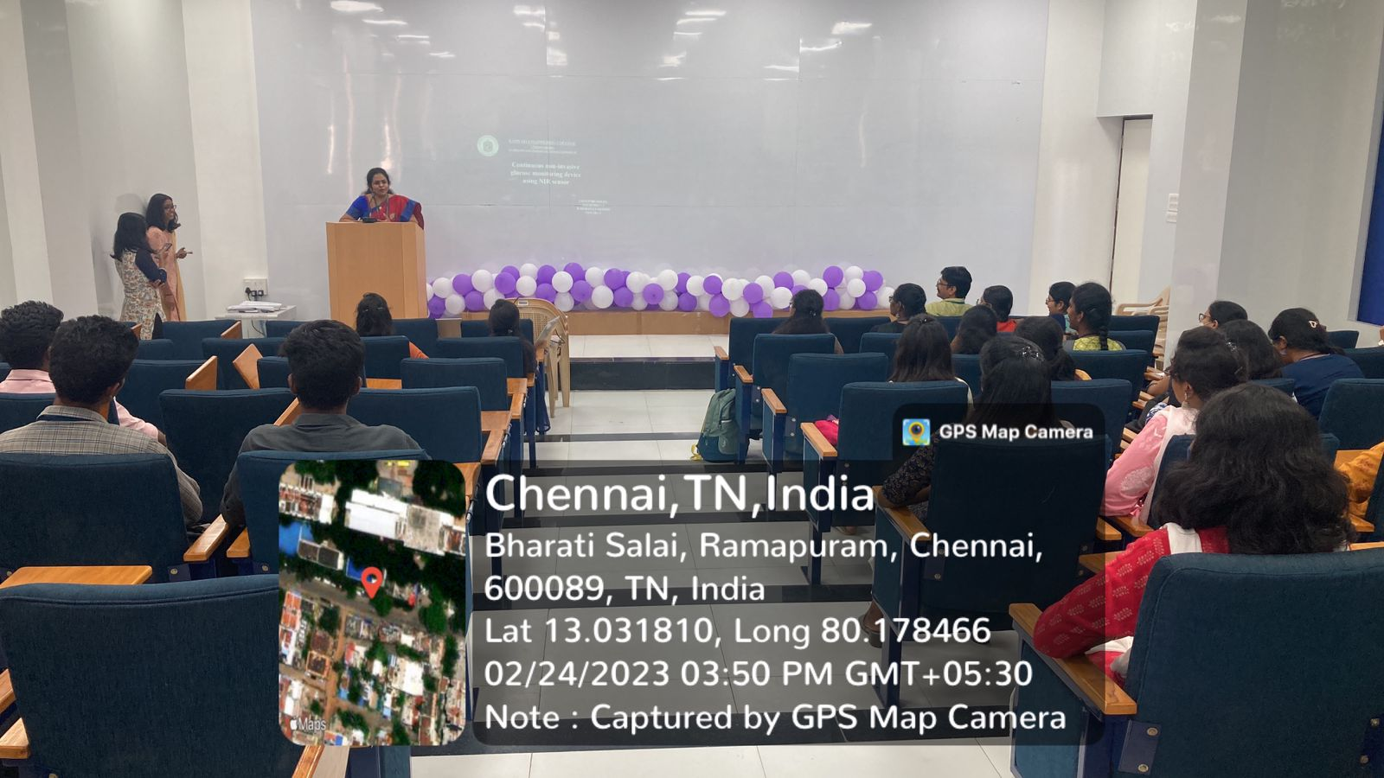
6. Pitch Talk session by EEE Department
Event Poster:
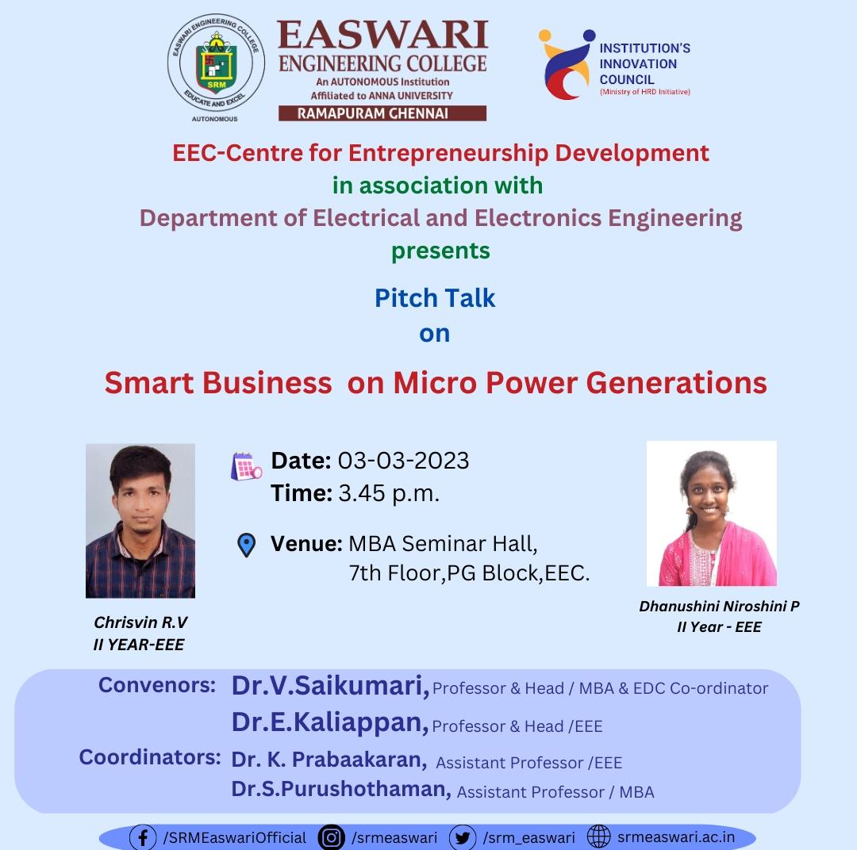
Event Report:
The Centre for Entrepreneurship Development of Easwari Engineering College completed the 'Pitch talk' session for CED EEC students. The session started with a welcome address given by Dr.Saikumari.V, Prof & Head MBA and EEC CED coordinator . The special address for the session given by Dr.Kaliappan, HOD-EEE. He appreciated for conducting several Entrepreneurship related activities in the campus for the Engineering students.

The student Mr.Chrisvin and Dhanushini from EEE department presented their 2 pitching ideas on the title smart business on micro power generation . The students of EEE attended the session along with MBA faculty and other engineering department EDC coordinators.
Event Photo:
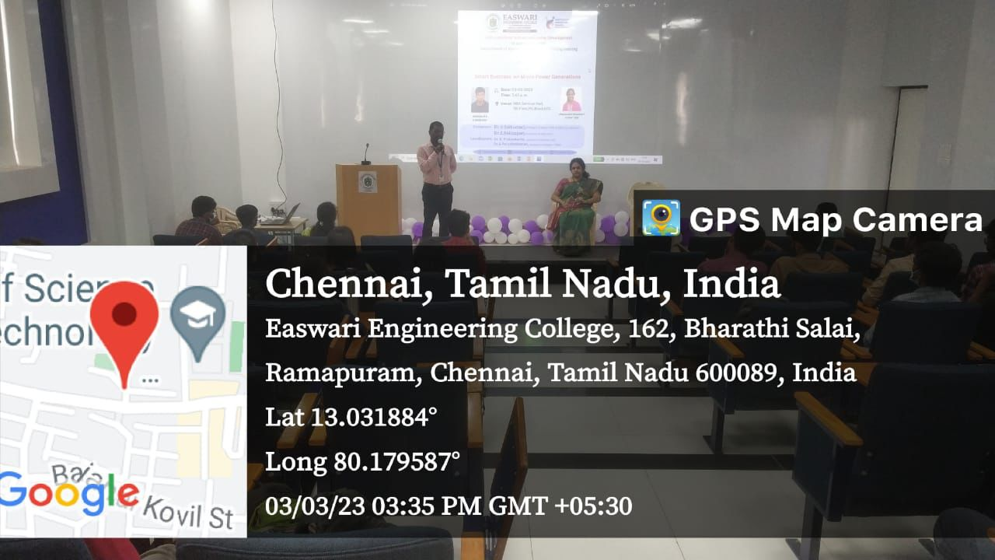
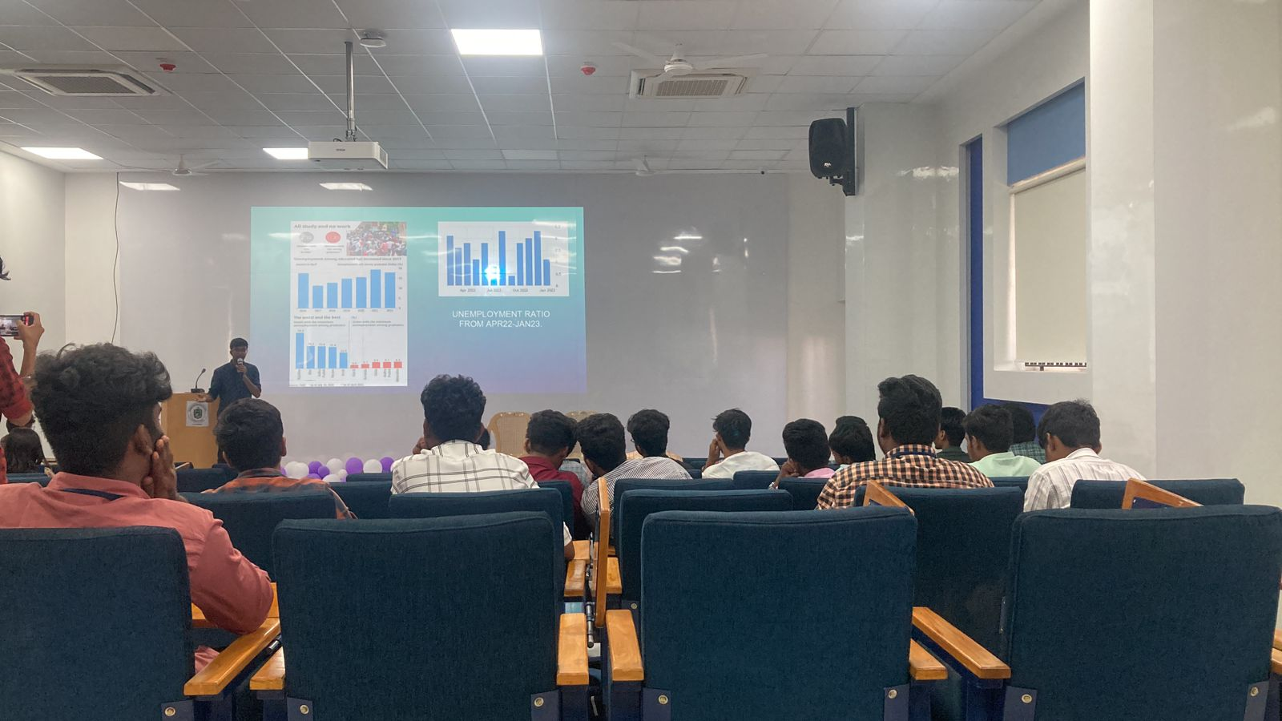
7. Pitch Talk session by AI&DS Dept
Event Poster:
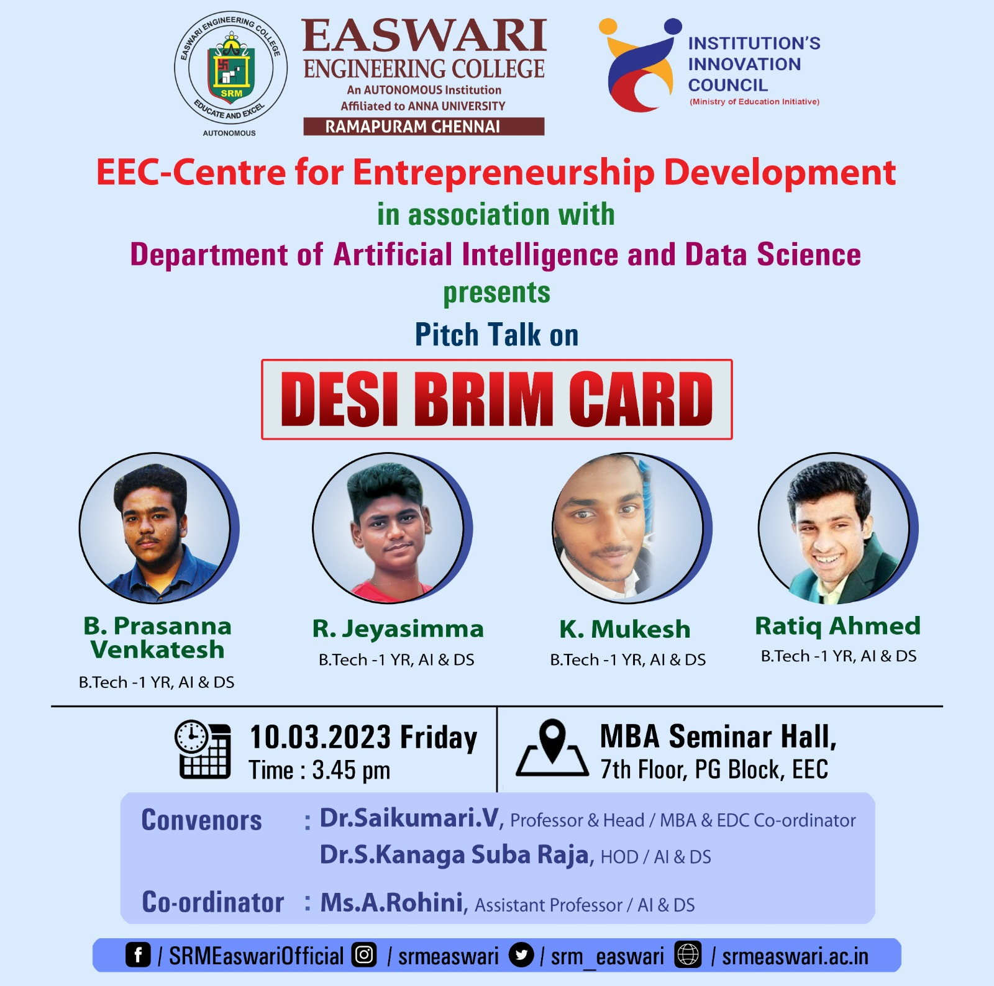
Event Report:
The Centre for Entrepreneurship Development of Easwari Engineering College completed the 'Pitch talk' session for CED EEC students. The session started with a welcome address given by Dr.Saikumari.V, Prof & Head MBA and EEC CED coordinator. The students from AI&DS attended the pitch talk session organized by EEC-CED. The students presented their business idea to the students under the title “ DESI Brim Card”.
Event Photo:
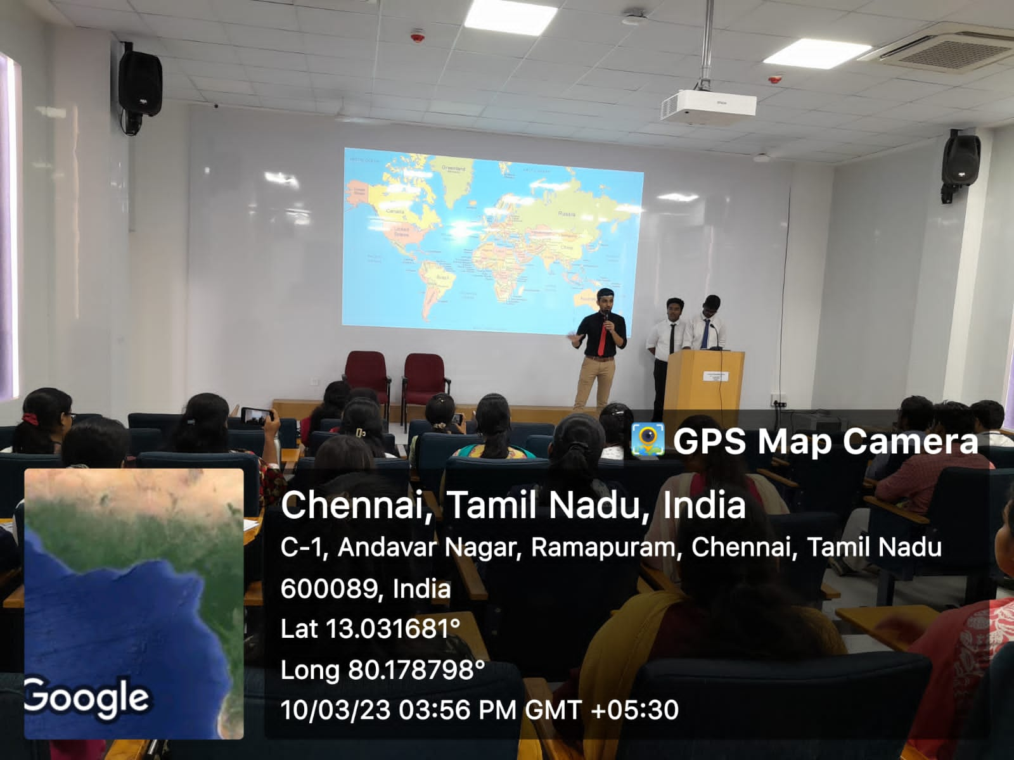
8. Pitch Talk session by MBA Dept
Event Poster:
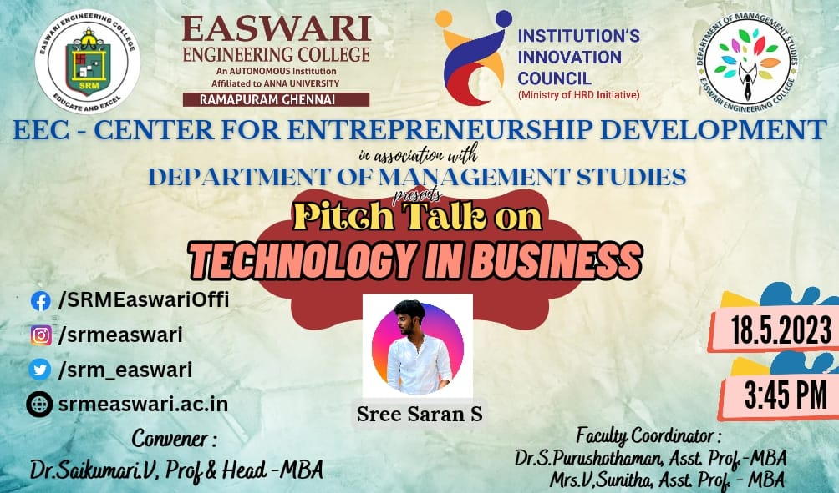
Event Report:
The Department of Management studies successfully completed the pitch talk for 1st year MBA students on the topic “Technology in Business” by Sree Saran and Munishwara Moorthy during the pitching session organized in association with Centre for Entrepreneurship Development.

The students explained the new technology used in the automobile industry for car detailing and machines used in bakery. The session ended with question and answer by the students.
Event Photo:
