EASWARI ENGINEERING COLLEGE
(AUTONOMOUS)
CENTRE FOR ENTREPRENEURSHIP DEVELOPMENT
ENTREPRENEURSHIP CONCLAVE
EVENT POSTER:
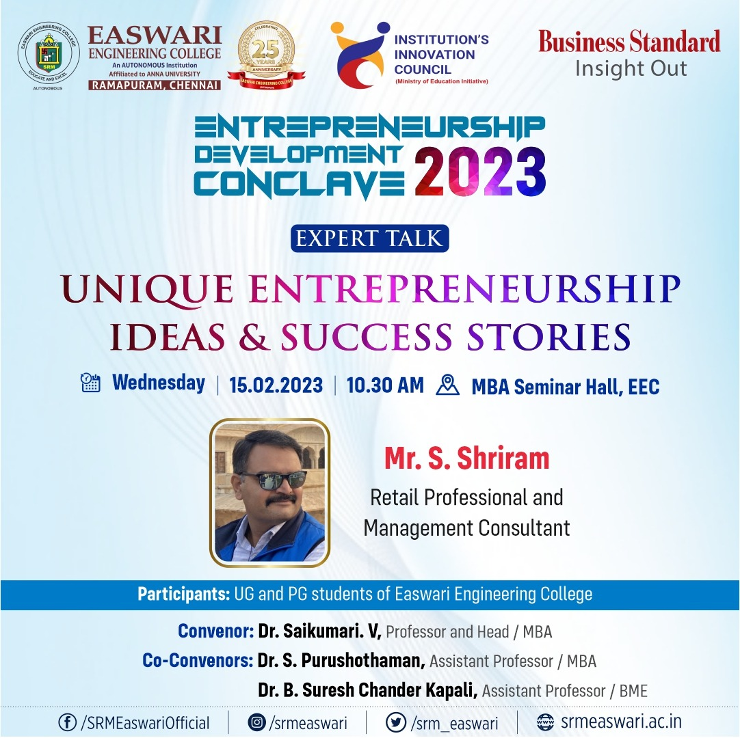
EVENT REPORT
The Centre for Entrepreneurship Development of Easwari Engineering College completed the 'Entrepreneurship Conclave 2023” for all EEC CED students. The session started with a welcome address given by Dr.Saikumari.V, Prof & Head MBA and EEC CED coordinator. During the event the CD consists on Alumni Entrepreneurs achievements was released by the chief guest.
The special address for the session given by Mr.Jayaraman, Deputy General Manager , Market Development , Business Standard. The chief guest invited for the session was Mr.Shriram , Retail Professional and Management Consultant. The speaker motivated the students for choosing the entrepreneurship as a career.
Followed by the expert talk the Business Plan and strategist competitions were conducted for the registered students. The winners will be given certificates.
Event Photo:
